CNS 1410 Object-oriented Programming

Project #7: TimeCard Application

Due Date:
Must be submitted no later than 1:00am on Monday.
Programs received prior to 1:00am on Sunday will receive 5 bonus points, if the program completely meets the specifications and executes correctly.

Objective:
To give student's experience constructing a program that uses
- Programmer defined classes
- Operator overloading
- A Graphical User Interface

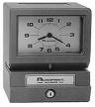
Project Overview:
In this project, you will create a simple timeclock application that uses a graphical user interface. Using your application, a user enters in their starting time and their quitting time. Your application will then calculate the number of hours that they have worked. The starting time and quitting time will be stored in objects of a Time class that you will design.

The Time Class
This project requires that you design a Time class. Objects of this class will be used to hold time values used by your program. In this project, it is up to you to decide what data members your Time class needs. However,
- You should be able to get Hours, Minutes, and an am/pm designation out of a Time object.
- You should design your class so that any calculations you do on Time objects are straightforward.
Your Time class should include at least the following functions:
- A constructor that takes the hour, minute, and an am/pm designation. These parameter values will be stored in the corresponding data members of the class.
- In order to calculate the amount of time worked, you will have to subtract one time object from another. To do this, you need to overload the - operator.
- To have a valid calculation, you will need to make sure that the quitting time entered by the user is after the starting time entered. To do this, you need to overload either the < (less than) operator or the > (greater than) operator.
- Getters for hour, minutes, and am/pm designation.
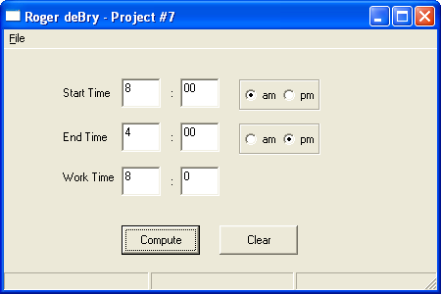

The Graphical User Interface
Your user interface should contain at least:
- Fields for the user to enter in a starting time, including an am/pm designation.
- Fields for the user to enter in a quitting time, including an am/pm designation.
- Fields to display the time worked.
- A button that will cause the program to calculate the hours worked, based on user input.
- A button that will clear all of the fields.
- A menu bar that provides a quit menu element and an about menu element. When the about element is clicked, your program should display a message box containing your name and "Project Seven".

Program Operation
The user types in a starting time and a quitting time. When the user clicks on the "Compute" button, your program will
- Read the time values input by the user
- Create Time objects to hold both the starting time and quitting time.
- Test to make sure that the qutting time is larger than the starting time. You will use the overloaded comparison operator to do this. If it is not, display a message box telling the user that the inputs were invalid.
- If the inputs are okay, then compute the number of hours worked by subtracting the starting time object from the ending time object.
- Display the time worked.
- If the user clicks on the Clear button, erase the contents of all fields.
- No other validation tests need to be done. You may assume that all times fall in the same day, i.e. a work day does not go past midnight.
Format and document your code in accordance with the course style guidelines. Include a file prologue identifying you as the author. Submit your project using the instructions outlined in the Course Syllabus, Programming Projects section.

File(s) to Submit:
All source code files, an executable file, and a UML class diagram for your Time class.

Grading
The Grade sheet is here
A sample executable can be found here.
You can find some hints for this project here.

